
PSYCHOLOGY
Response 1
Biological Influences Test
STAGE 3 2015

Student name __________________________________________

Time allowed for this paper
Working time for paper: 60 min 60 marks 5% of course

Part A: Research Methods (10 marks)

Read the following scenario and answer the questions that follow

Renowned Perth Psychologist, Dr. Wrona, was interested in the relationship between sleep levels and an individual’s mood state. After putting an advertisement in a local newspaper, she gathered 50 volunteers (ages 18-65), who experienced the following hours of sleep per night: 1-4 OR 6-9. She then asked them a series of open-ended questions in her clinic in order to understand the nature of their respective mood states

1a. State the IV/s. (1 mark)
________________________________________________________________________________________________________________________________________________________________________________

b. State the DV. (1 mark)

________________________________________________________________________________________________________________________________________________________________________________

c. Create an operationalised hypothesis for this research study. (2 marks)
________________________________________________________________________________________________________________________________________________________________________________
________________________________________________________________________________________________________________________________________________________________________________
d. Outline the type of data collected by the psychologist. (2 marks)
________________________________________________________________________________________________________________________________________________________________________________
________________________________________________________________________________________________________________________________________________________________________________

e. Describe one disadvantage/limitation of using this form of data. (2 marks)
________________________________________________________________________________________________________________________________________________________________________________
________________________________________________________________________________________________________________________________________________________________________________
f. Describe another type of data that Dr. Wrona should use in conjunction with the data she has already collected. (2 marks)
________________________________________________________________________________________________________________________________________________________________________________
________________________________________________________________________________________________________________________________________________________________________________

Part B: Biological Influences (50 marks)

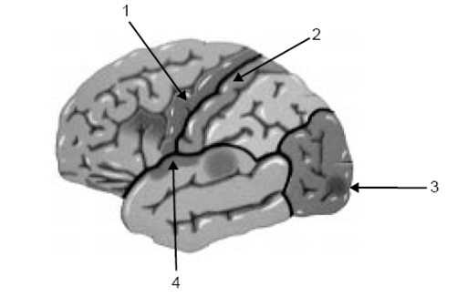

2a. Identify all four lobes of the cerebral cortex, as shown above, and outline the functional areas within each lobe. (10 marks)
________________________________________________________________________________________________________________________________________________________________________________
________________________________________________________________________________________________________________________________________________________________________________
________________________________________________________________________________________________________________________________________________________________________________
________________________________________________________________________________________________________________________________________________________________________________________________________________________________________________________________________________________________________________________________________________________________
b. Identify one behavioural change that might occur as a result of damage to the frontal lobe, with reference to empirical research. (3 marks)
________________________________________________________________________________________________________________________________________________________________________________________________________________________________________________________________________________________________________________________________________________________________________________________________________________________________________________________
c. Psychologists have a ‘map’ of the primary motor cortex, and are able to identify which areas of the cortex are dedicated to specific movements. Using an example, outline the investigation method which helped this occur. (3 marks)
________________________________________________________________________________________________________________________________________________________________________________________________________________________________________________________________________________________________________________________________________________________________________________________________________________________________________________________

4a. Dr Adair has a patient who has damaged their frontal lobe, and is displaying problems with speech production as a result. Identify and define which disorder the patient has. (2 marks)
________________________________________________________________________________________________________________________________________________________________________________
________________________________________________________________________________________________________________________________________________________________________________
b. Compare and contrast the disorder above to another speech production disorder, referencing site of damage, fluency of speech, and meaning of speech. (4 marks)
________________________________________________________________________________________________________________________________________________________________________________
________________________________________________________________________________________________________________________________________________________________________________
________________________________________________________________________________________________________________________________________________________________________________

4. Define what an EEG is, and identify what is often used for. (2 marks)
________________________________________________________________________________________________________________________________________________________________________________
5. Dr Notman wants to find out which areas of the brain are involved with certain activities, such as reading or maths in children. Which form of scanning technique should he use and why. (4 marks)
________________________________________________________________________________________________________________________________________________________________________________
________________________________________________________________________________________________________________________________________________________________________________________________________________________________________________________________________________________________________________________________________________________________

6a. A patient is complaining of headaches and Dr Wood thinks it may be a tumour. Which form of brain scanning or external recording device/s should she use and why. (3 marks)
________________________________________________________________________________________________________________________________________________________________________________
________________________________________________________________________________________________________________________________________________________________________________________________________________________________________________________________________
b. Discuss two limitations of using this method of investigation. (2 marks)
________________________________________________________________________________________________________________________________________________________________________________________________________________________________________________________________________
7a. Define ablation. (1 mark)
________________________________________________________________________________________________________________________________________________________________________________
b. Identify one researcher associated with animal research, and outline their contribution to this area of research. (4 marks)
________________________________________________________________________________________________________________________________________________________________________________
________________________________________________________________________________________________________________________________________________________________________________________________________________________________________________________________________________________________________________________________________________________________

6a. Complete the diagram of the Nervous System, below. (4 marks)
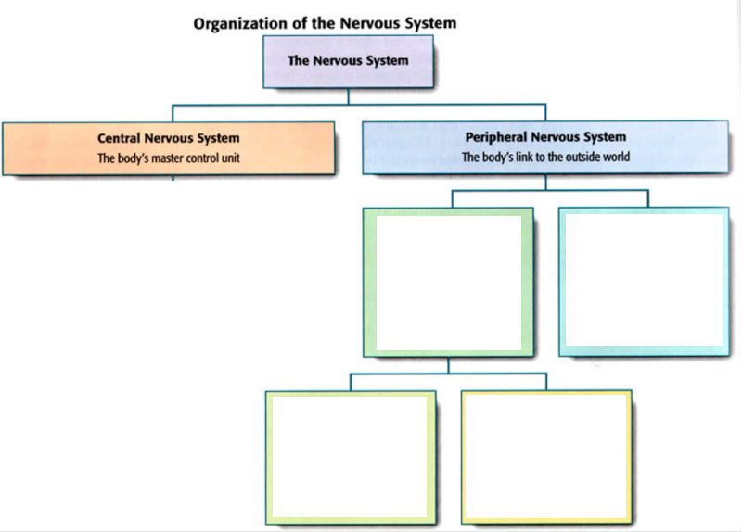
b. Define the central nervous system. (1 mark)
________________________________________________________________________________________________________________________________________________________________________________
c. Define the somatic nervous system, and outline its relationship with the central nervous system. (3 marks)
________________________________________________________________________________________________________________________________________________________________________________________________________________________________________________________________________________________________________________________________________________________________
d. Homeostasis can be defined as a point of “balance” or “physiological equilibrium” in an individual. Explain the functioning of the two branches of the autonomic nervous system in relation to homeostasis. (4 marks)
________________________________________________________________________________________________________________________________________________________________________________________________________________________________________________________________________________________________________________________________________________________________________________________________________________________________________________________________________________________________________________________________________________
END OF TEST

